

# Name: Hamza naveed

# Intern ID: TN/IN02/PY/010

# Email ID : hamza.live.016@gmail.com

# Task week: 04

# Internship Domain: Python Development

# Instructor Name: Mr. Hassan Ali

# 

# 

# Tasks – Libraries and pip

## Task 01

### Step-by-Step Instructions

### Code & Output Snippet

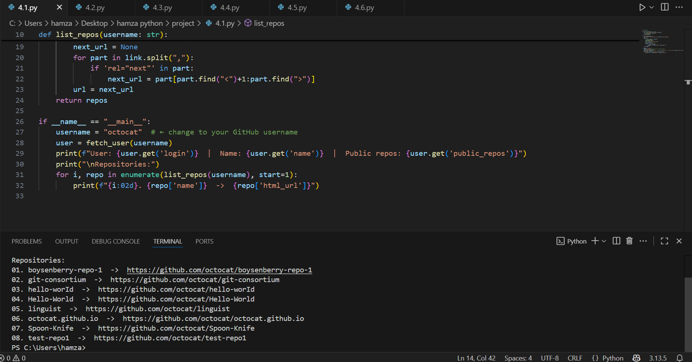

### Learning and Challenges

* Learned how to take input and printing values
* Handling number input

## Task 02

### Code Output Snippet

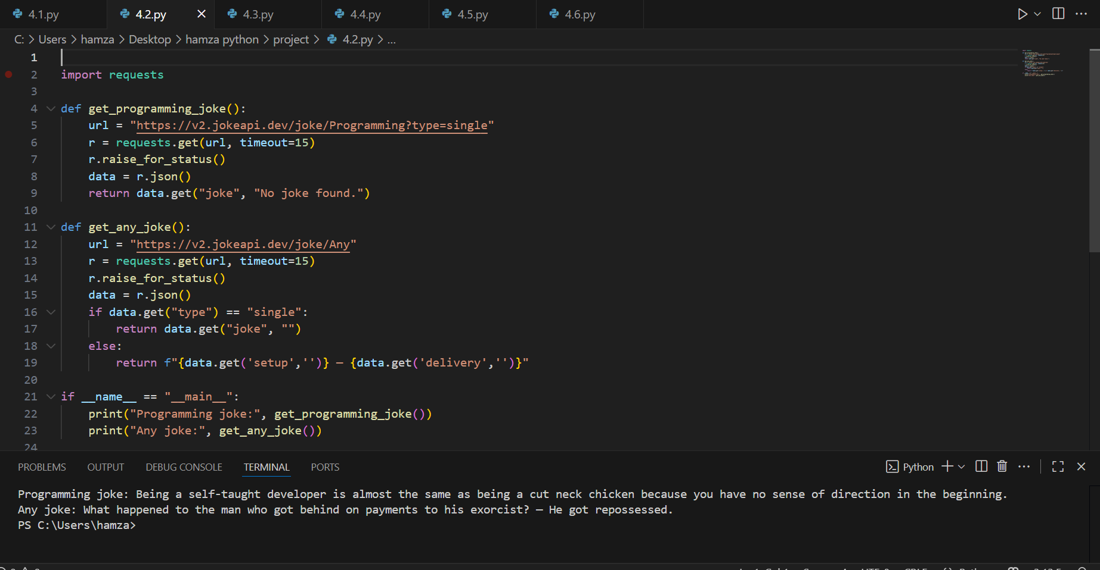

### Learning and Challenges

* Learned how to use python multiple assignments (a,b=b,a)
* Rimbering the syntex

## Task 03

### Code Output Snippet

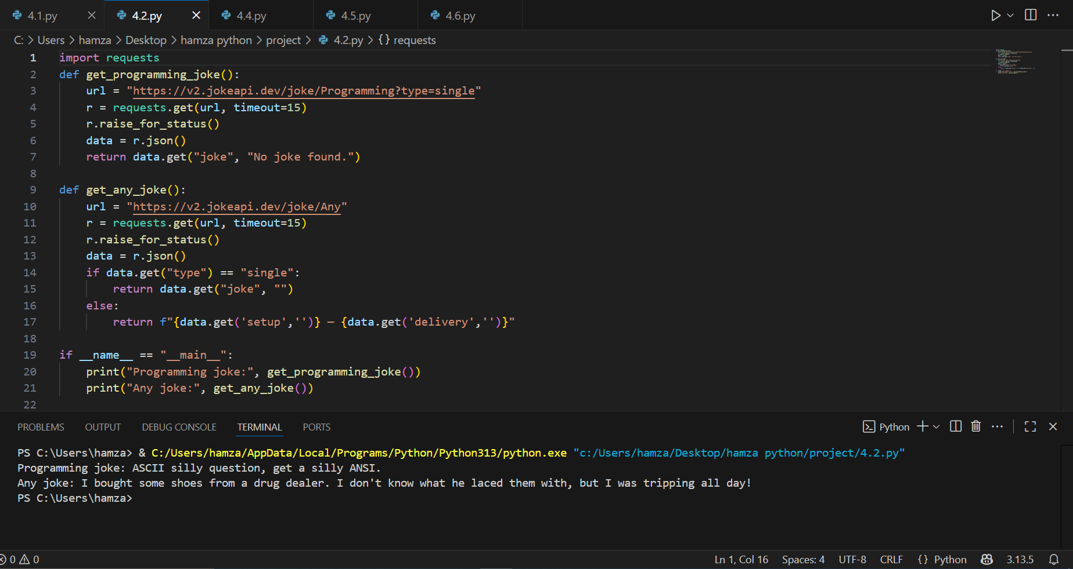

### Learning and Challenges

* Learned how to take multipl inputs and use floar()
* .issues in understanding float and int

## Task 04

### Code Output Snippet

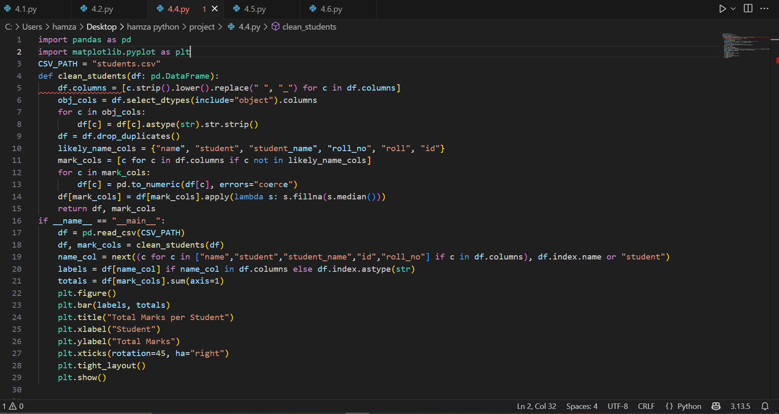

### Learning and Challenges

* Learned hoe to use integer divion and modulo
* Cunfude between / and %

## Task 05

### Code Output Snippet

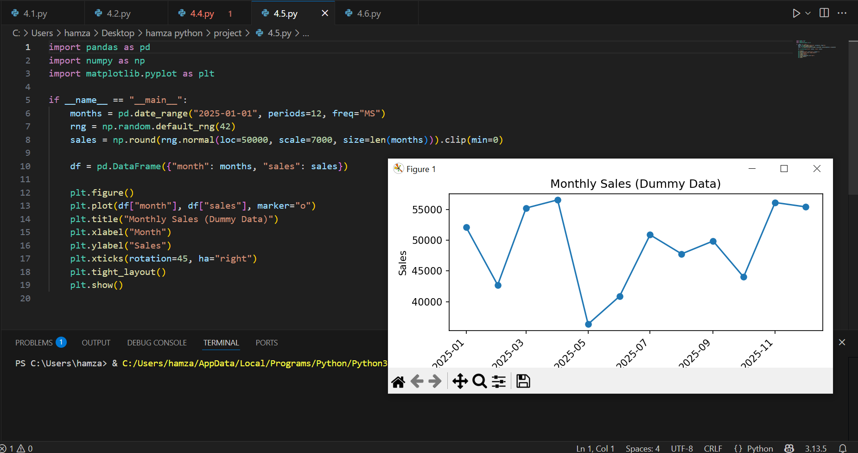

### Learning and Challenges

Learned how to use formulas in python

Remembering correct formula

## Task 06

### Code Output Snippet

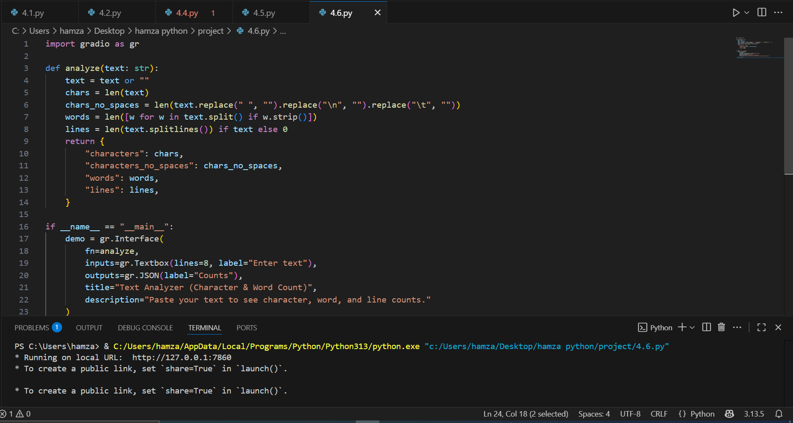

### Learning and Challenges

Learned how to use String methods (split(), lower()).

Not understanding Trimming extra spaces.